22nd Annual
Blakemore UMC Retreat

“The Incredible 2016 Retreat”
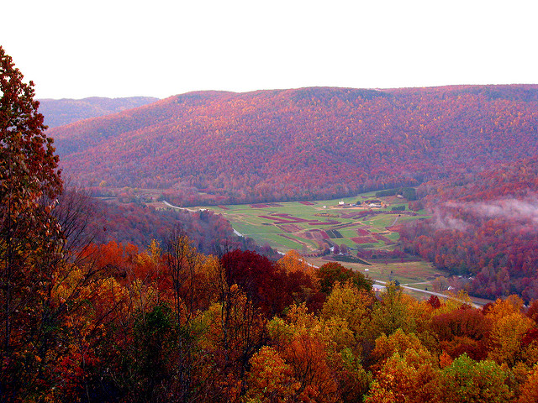

@ Beersheba Springs Assembly

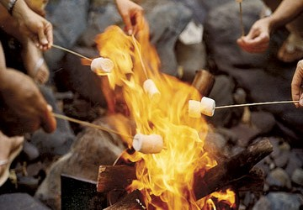

October 21-23, 2016
Choose the Room Type and the number of nights.

No more than 4 adults or 5 per family per room for fire and safety reasons
Occupancy tax is 5% on top of room expense only
_______________________________________________________

Meals (age 9 +): Breakfast $8.50, Lunch $9.50, Dinner $12.00
Meals (ages 4-8): Breakfast $4.25, Lunch $4.75, Dinner $6.00
Children age 3 and under eat free (just list their names below)

Room Name | Type of Room |  |  | # of nights | Circle Your Choice of Room
Vintage | Bath house, fan and space heater |  |  | 1 | $47.25
Vintage | Bring your own bedding |  |  | 2 | $94.50
Modern | Private bathroom, sheets & towels |  |  | 1 | $72.45
Modern | Air conditioner & Heater |  |  | 2 | $144.90
Name of Attendee |  | Child Age |  | # of Meals | Meal Cost
1.
2.
3.
4.
5.
Cost of Retreat Supplies |  |  |  |  | 5.00
 |  |  | Total Cost

Please list your phone numbers and email address so that we can contact you with room assignments and other information:

Home Phone:_______________________________________________________________
Cell Phone:________________________________________________________________
Email Address: _____________________________________________________________

If you need scholarship assistance, please see Rev. John Hill or Deanna McCulley. If you have special needs, like handicap access, dietary restrictions, or other medical or physical limitations, please indicate here: _______________________________________________________________
__________________________________________________________________________
__________________________________________________________________________

Funds are due at the time of registration and are non-refundable after September 21st. All reservations should be submitted by Wednesday September 21st, after that date, there is no guarantee of room availability. Make your checks payable to Blakemore UMC and return the form with your check to Deanna McCulley or the Church office. You can call, email, or look for me on Sunday mornings.

If you have any questions about cost or rooms, please contact:
Deanna McCulley 615-604-1481
Deanna.McCulley@gmail.com
DMcCulley@equitableco.com

Bring your instrument to play, walking or hiking shoes, and your appetite.

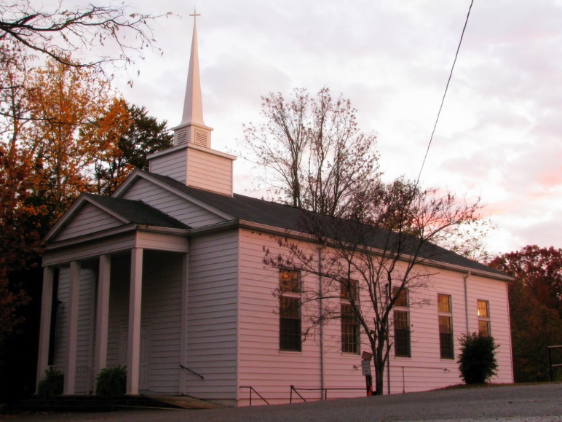

If you have any questions at all please contact:
Deanna McCulley 615-604-1481
Deanna.McCulley@gmail.com
DMcCulley@equitableco.com

